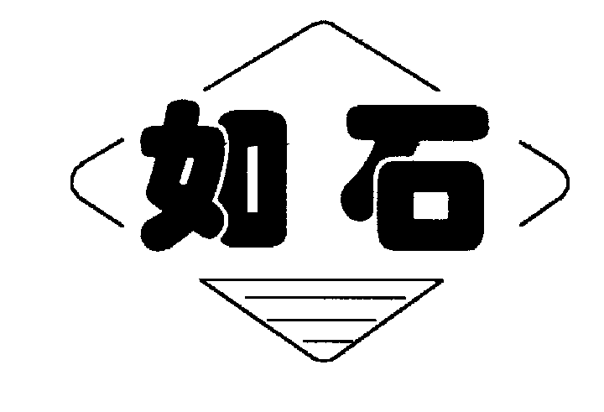

SE500

CASING ELEVATOR/SPIDER

OPERATION MANUAL
QD500-SM
STANDARD: Q/320623AD16

JIANGSU RUSHI MACHINERY CO.,LTD
Add：No.60 Weihai North-Road, Bencha, Rudong, Jiangsu, China P.C.：226406
Tel：0513-84890912 84890937 Fax：0513-84821168
http://www.jsrushi.com E-mail:rslzg@jsrushi.com

CONTENTS

1. pRODUCT INTRODUCTION
2. MAIN TECHNICAL PARAMETERS
3. Main Parts Structure and Working Principle
4. INSTALLATION
5. Operation Instructions
6. lUBRICATION
7. Maintenance
8. Trouble shooting

1. Product Introduction
SE500 casing elevator/spider is a kind of pneumatically operated well head tools, applicable for onshore and offshore casing operation. It can handle casing ranging from 4” to 14”. By operating the reversing air valve may bring slips up or down to clamp or release casing. Meanwhile, the lock device on control valve may lock slips safely.
SE500 casing elevator/spider can be used alone as a spider, or as an elevator. The elevator is fitted with a bell guide and bottom guide. The spider is fitted with a top guide that centers the spider over the master bushing. (Fig. 1)
The elevator is attached to the derrick traveling block and hook with 350 or 500 ton standard API links. The Spider locates directly on the pin drive master bushing (27 1/2 MSPC, 37 1/2 and 49 1/2 MPCH), and square drive master bushing (27 1/2 MSS), and will accommodate any other master bushing when used with an Adapter Plate.
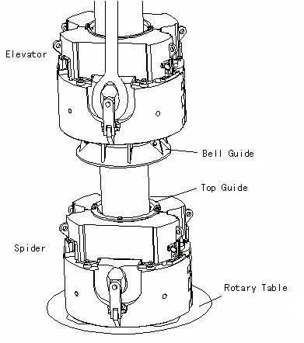
Fig.1

2. Technical Parameters
2.1 Applicable casing OD 101.6-355.6mm (4-14in)
2.2 Load capacity 4500kN
2.3 Air pressure 0.6-0.8MPa
2.4 Dimensions of elevator 1300*1052*1110mm
2.5 Dimensions of spider 1300*1052*890mm

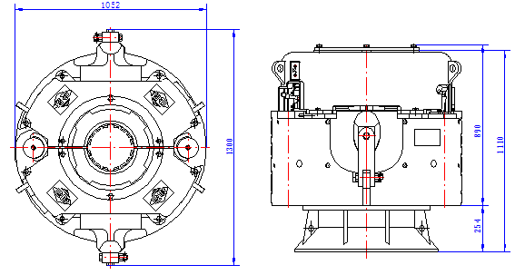
Fig.2

2.6 Weight of elevator 2780 kg (with one slip assembly)
2.7 Weight of spider 2690kg (with one slip assembly)
2.8 Design and lowest working temperature -20℃
2.9 Refer to the following table 1 for Specification of slip assemblies, inserts, bell guides, and top guides.

Table 1:
Casing Size(in) | Slip Body Size | Inserts |  |  |  | Elevator | Spider
Casing Size(in) | Slip Body Size | Inserts | Number | Beveled Inserts | Number | Bell Guide | Top Guide
4 | 5.1/2 |  | 32 |  | 16 | 4-4.1/2 | 4-4.1/2
4.1/2 | 5.1/2 | RS2168 | 32 | RS 2168B | 16 | 4-4.1/2 | 4-4.1/2
5 | 5.1/2 | RS 2169 | 32 | RS 2169B | 16 | 5 | 5
5.1/2 | 5.1/2 | RS 2170 | 48 |  |  | 5.1/2-5.3/4 | 5.1/2-5.3/4
5.3/4 | 5.1/2 |  | 48 |  |  | 5.1/2-5.3/4 | 5.1/2-5.3/4

Casing Size(in) | Slip Body Size | Inserts |  |  |  | Elevator | Spider
Casing Size(in) | Slip Body Size | Inserts | Number | Beveled Inserts |  |  | Inserts
6.5/8 | 7.5/8 | RS2632 | 48 | RS2632B | 24 | 6.5/8-7 | 7
7 | 7.5/8 | RS2623 | 48 | RS2623B | 24 | 6.5/8-7 | 7
7.5/8 | 7.5/8 | RS2633 | 72 |  |  | 7.5/8-7.3/4 | 7.5/8-7.3/4
7.3/4 | 7.5/8 | RS2649 | 72 |  |  | 7.5/8-7.3/4 | 7.5/8-7.3/4
8.5/8 | 9.5/8 | RS2640 | 64 | RS2640B | 32 | 8.5/8-8.3/4 | 8.5/8-8.3/4
8.3/4 | 9.5/8 | RS2650 | 64 | RS2650B | 32 | 8.5/8-8.3/4 | 8.5/8-8.3/4
9.5/8 | 9.5/8 | RS2633 | 96 |  |  | 9.5/8 | 9.5/8
9.3/4 | 9.5/8 | RS2649 | 96 |  |  | 9.3/4-9.7/8 | 9.3/4-9.7/8
9.7/8 | 9.5/8 | RS2649 | 96 |  |  | 9.3/4-9.7/8 | 9.3/4-9.7/8
10.3/4 | 11.3/4 | RS2640 | 80 | RS2640B | 40 | 10.3/4-10.7/8 | 10.3/4-10.7/8
10.7/8 | 11.3/4 | RS2650 | 80 | RS2650B | 40 | 10.3/4-10.7/8 | 10.3/4-10.7/8
11.3/4 | 11.3/4 | RS2637 | 120 |  |  | 11.3/4-11.7/8 | 11.3/4-11.7/8
11.7/8 | 11.3/4 | RS2651 | 120 |  |  | 11.3/4-11.7/8 | 11.3/4-11.7/8
12.3/4 | 14 |  | 80 |  | 40 | 12.3/4 | 12.3/4
13.3/8 | 14 | RS2636 | 80 | RS2636B | 40 | 13.3/8 | 13.3/8
13.1/2 | 14 | RS2652 | 80 | RS2652B | 40 | 13.1/2-13.3/4 | 13.1/2-13.3/4
13.5/8 | 14 | RS2653 | 80 | RS2653B | 40 | 13.1/2-13.3/4 | 13.1/2-13.3/4
13.3/4 | 14 | RS2655 | 80 | RS2655B | 40 | 13.1/2-13.3/4 | 13.1/2-13.3/4
14 | 14 | RS2635 | 120 |  |  | 14 | 14

3. Main Parts Structure and Working Principle
3.1 Main Parts Structure
SE500 casing elevator/spider mainly involves housing assembly (include house, active hinged pin, etc.), balance beam assembly, spider assembly (include slips, inserts, etc.), air line assembly (include control valve), air cylinder parts and manual socket.
3.2 Working principle
Operating reversing valve will activate air cylinders to raise or lower the slips. The slips are suspended on two inter-locking leveling beams that are driven by four air cylinders. This feature allows the slips to operate in synchronization in both the set and raised positions, while permitting the cylinders to work together so no one cylinder overrides any other, causing misalignment and binding. A manual override system is also provided in the event of a temporary loss of rig air pressure.
A G1/2” filter-regulator (to be prepared by user) will regulate and filter the rig air and send it to the lubricator (mounted on the Elevator and Spider) to add a small amount of oil mist to lubricate the four drive cylinders. The air from the lubricator is sent to the control valve that operates the leveling beams. As directed by the control lever, the air cylinders will raise or lower the slips attached to the leveling beam.

4. Installation
4.1 Prepare a G1/2” filter-regulator and a tee joint.
4.2 Refer to Table 1 and check slips, inserts, bell guide and to guide for meeting the casing size to handle. And ensure all the parts are fixed correctly in place. Refer to Fig.1 and Fig.3 for installation.

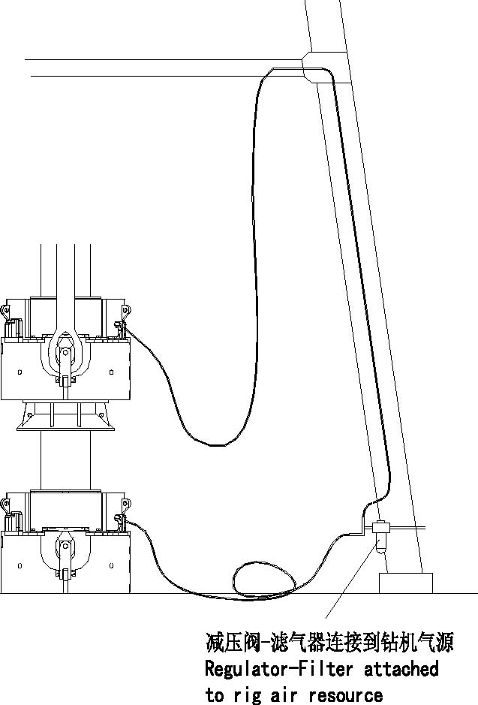

Regulator-Filter attached to rig air resource
4.3 Installing spider
The spider should be set on master bushing, and fastened by anchor chain. If opening of rotary table is less than 20 1/2” I.D., (with bushing removed), it is needed to install the adaptor plate on the top of rotary table.
4.4 Installing elevator
Attach links to two ears of Elevator and secure with bolts.
4.5 Connecting Air Lines
4.5.1 Mount regulator-filter at a location on derrick. Connect air-in end with air source and the air-out end with a tee joint, which will connect Elevator and Spider respectively.
4.5.2 Attach a 50 foot long, 1/2” air line between Elevator and the Stand Pipe located 45 feet above the rig floor, near the derrick stabbing board. Both ends of air lines are quick disconnecting type.
4.5.3 Attach a 25 foot 1/2” air line between Spider and regulator-filter.
4.5.4 Attach rig air line to regulator-filter and adjust regulator to 0.7-0.8MPa.
Note: If the regulator-filter will not remain permanently with rig, use two 50 foot air lines. Tie one 50 foot section of hose 45 feet above floor near casing stabber. Attach second section of hose to first hose with the other end to Elevator.
4.6 Removing and Replacing Slip Segments
4.6.1 Removing Slip Segments-Fig.4
a. Power the slip segments to the up position.
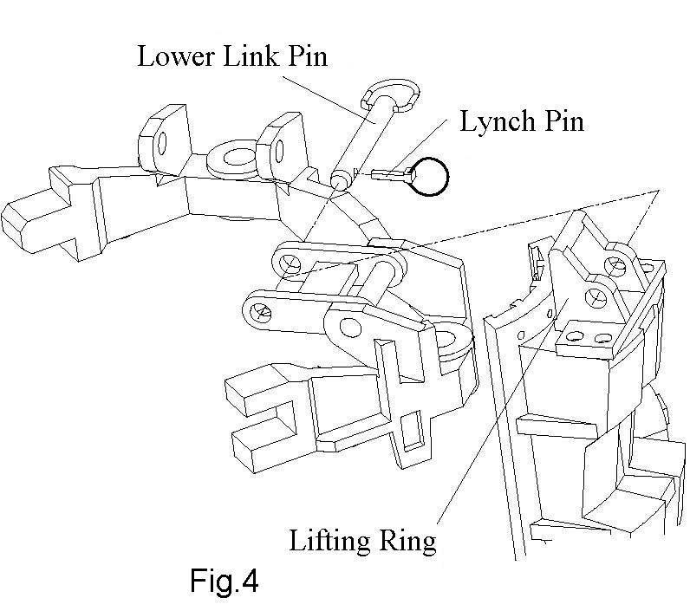
b. Connect an overhead lift hook into slip segment lifting ring. With the weight off the remove lynch pin.
c. Remove link pin.
d. Remove a single slip segment.
e. Repeat steps b through c and remove other slip segments.
4.6.2 Installing Replacement Slip Segment
a. Apply liberal amount of multi-purpose grease to back of replacement slip segment and mating bowl surfaces.
Note: Back of segment and inside of Spider must be clean before applying grease and slip segments.
b. Using the hoist, lower the required slip segment in place, aligning link with mating hole on slip segment.
c. Install lower pin in place and insert lynch pin in lower pin.
d. Repeat steps a through c to install other slip segment.
4.7 Removing and Installing Guides
4.7.1 Removing Guides-Fig.5
a. Remove removable hinge pin with lift.
b. Spread hinged body to provide access to guides.
c. Remove bolt and keeper from each side of guide ring.
d. With an overhead lift, raise the Spider body off the floor and block-up at about 100mm.
e. Slide guide ring out of slot in house body.
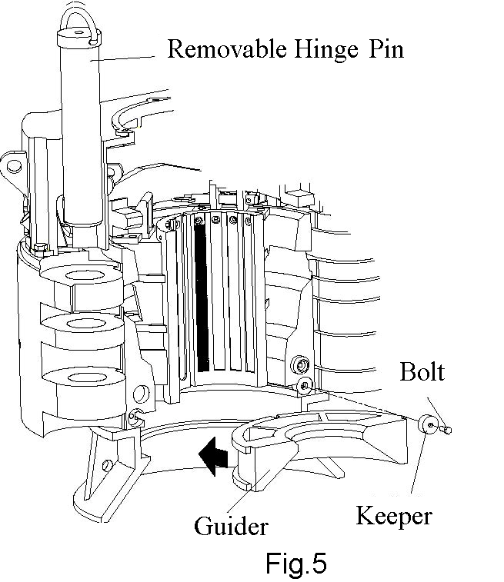
4.7.2 Installing Guides
a. Insert new guides into slot of house body and secure in place with bolts and keeper.
b. Lift and close Elevator/Spider house body and insert hinge pin.
c. Operate slip segments to determine proper operation, as indicated in Section 5.

5. Operation Instructions
5.1 Operation
The Elevator and Spider operation is controlled by a lever operated, control valve located on the body of each unit. (Fig.6)
5.1.1 Moving the lever to the up position raises the slips.
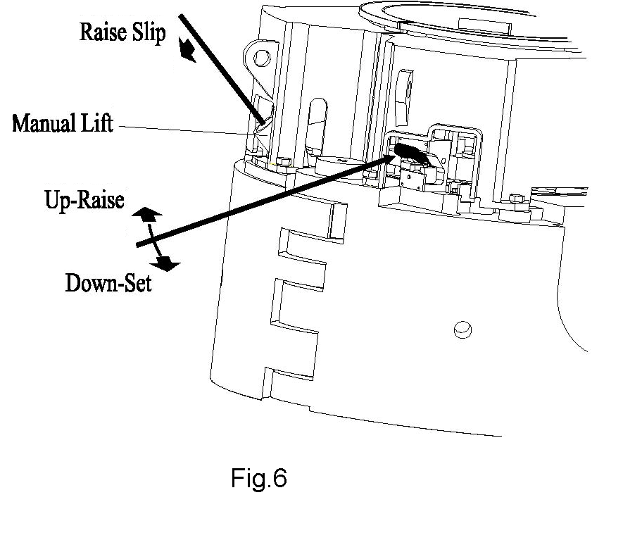
5.1.2 Moving the lever to fully down position sets the slips.
If an air pressure failure should happen, the slip segments can be operated manually, as follows：
a. Place a 5 foot pry bar into manual lift lever.
b. Push down on pry bar and move the control lever handle to the up position. This moves the latch plate under the leveling beam to hold slips in the up position.
c. To set slips (lower slips) push control lever handle down.
5.2 Attentions for operation
5.2.1 Only operate the Elevator/Spider when pipe to handle completely stops, or it will get stuck.
5.2.2 It is necessary to use backup casing tong during making-up or breaking-out. As the Elevator/Spider do not have the function of anti-torque.
5.2.3 Remember to secure the spider with anchor chain and make spider center identical with wellhead center.
5.2.4 Lowering speed should be very slow when casing coupling going through Elevator/Spider inside.
5.2.5 Add fluid oil after every 50 joint casing run. If sticking of slips happens in the house body, inject fluid oil between house body and slips. (Fluid oil may bring away impurities.)

6. Lubrication
Lubricate after every 50 joint casing run and more frequently if necessary to prevent slips from sticking in the Elevator or Spider Body. To lubricate properly the slips should be in the set position without any casing load on unit.
Table 2
No. | Item | Number of Lube Point | Application | Lube Cycle
1 | Bowl/Slip Surfaces | 16 | Multi-Purpose  Waterless Grease | See Note Below
2 | Cylinder Assemblies | 4 | Multi-Purpose  Waterless Grease | Before Each Job
3 | Hinge Pins | 2 | Multi-Purpose  Waterless Grease | Before Each Job
4 | Flow Control Valve | 2 | Multi-purpose  Waterless Grease | Weekly
5 | Link Pins | 8 | SAE 10 oil | Weekly

7. Maintenance
7.1 Preventive Maintenance
DO’S
1. Lubricate are required in Table 2.
2. Check guides and gripping inserts for wear and replace as require.
3. Avoid unnecessary shock loading of slip segments.
Warning: The plastic bowl used on this device can be damaged and possibly fail if exposed to certain solvents, strong alkaline substances, or compressor oils containing aromatic hydrocarbons (fire retardant oils). Fumes of these substances in contact with the bowl can cause damage to the bowl.
DON’TS
1. Never paint over moving parts or grease fittings.
2. Avoid unnecessary impact load on slips.
3. Avoid contamination of air lines.
4. Never restrict air flow.
5. Avoid dry or over-oiled lubricator.
6. Never use equipment that is not opening properly.
7.2 Transportation and Storage
7.2.1 Crash is forbidden when in transportation of the elevator. It must be prevented from rain.
7.2.2 The products must be stored in the dry and well-ventilated place and prevented from in the sun or in the rain. It is forbidden to let the products contact acids, alkalis, salts and some other corrosion substance.

8. Troubleshooting

Troubles | Reasons | Solutions
Slip Segments do not operate or operate slowly in both directions | a. Air pressure at regulator not in the range 0.6-0.8MPa.  b. Air lines are pinched or kinked leaks which could decrease air pressure.  c. Not enough oil in lubricator and operation of the drive cylinders is affected.  d. Control valve fails to work.  e. Dust ring in cylinders is worn and restrict cylinder action. | a. Adjust the regulator to pressure at 0.6-0.8MPa.  b. Straight out the air lines.  c. Add oil to lubricator until the cylinders can work normally.  d. Repair or replace the valve.  e. Replace the dust ring.
Pipe Slips | a. One or two incorrect slip segments mixed with correct size slip segments.  b. Worn or damaged inserts.  c. Back of slip segment is worn | a. Check and replace with correct segments.  b. Replace inserts.  c. Repair or replace slips.
Damage on pipe | a. There is incorrect slip segment in slip assembly.  b. Badly worn or damage of inserts. | a. Check and replace with correct segments.  b. Replace inserts.

Exploded View of SE500 Casing Elevator/Spider

Parts List of SE500 Casing Elevator/Spider
No. | Part No. | Description | Qty.
1 | RS297.000-（01～15） | Top Guide(4-14") | 2/each
2 | ASME | BOLT, Hex Head 3/4"-10×2" | 6
3 | ASME | LOCKWASHER 3/4" | 6
4 | RS297.000-01 | Cover | 2
5 | RS297.200-02 | LINK PIN, Upper | 4
6 | RS297.200-03 | LINK, Slip Hanger | 4
7 | ASME | NUT, Hex, 1.1/4"-12UNF | 4
8 | ASME | LOCKWASHER 1.1/4" | 4
9 | ASME | FLATWASHER 1.1/4" | 4
10 | RS297.200-01 | LEVELING BEAM | 2
11 | RS297.210.00 | LINK PIN, Lower | 4
12 | RS297.100-03 | CAPSCREW, Modified | 2
13 |  | GREASE FITTING, 1/8 NPT | 18
14 | RS297.300.00 | SLIP SEGMENT | 4/each
15 | ASME | CAP SCREWS 3/4" -10×2" | 2
16 | RS297.100-05 | BUTTON, Register | 2
17 | RS297.100-06 | GUIDE,KEPPER | 4
18 | ASME | BOLT, Hex Head,1"-8×2-1/2" | 4
19 | ASME | LOCKWASHER 1" Dia. | 4
20 | RS297.000-29 | GUIDE RING | 2
21 | RS297.600.00 | BELL GUIDE | 2
22 | RS297.100-01 | BODY | 2
23 | ASME | BOLT, Hex Head, 1/2" -13x1-1/2 | 8
24 | ASME | LOCKWASHER 1/2" Dia. | 8
25 | RS297.220.00 | LYNCH PIN | 4
26 | GB/T91 | COTTER PIN 5×40 | 8
27 | RS297.110.00 | HINGE PIN, Removable | 1
28 | RS297.110-02 | HINGE PIN, Stationary | 1
29 | ASME | BOLT, Hex Head,5/8"-11×1-3/4" | 10
30 | ASME | LOCKWASHER 5/8" | 18
31 | RS297.520.00 | LUBRICATOR MOUNTING BRACKET | 1
32 | ASME | BOLT, Hex Head,1/2"-13×1.1/2" | 8
33 | RS297.000-31 | RETAINER CYLINDER | 8
34 | GB/T91 | COTTER PIN 6.3×40 | 2
35 | ASME | NUT, Hex slotted 1" | 2
36 | RS297.100-02 | CATCH,LINK | 2
37 | RS297.100-04 | BOLT | 2
No. | Part No. | Description | Qty.
38 | RS297.510.00 | CONTROL VALVE and LATCH ASSEMBLY | 1
39 | RS297.700-02 | PIN,PIVOT φ25.4 | 1
40 | GB/T91 | COTTER PIN 3.2×40 | 2
41 | RS297.700-01 | MANUAL CONTROL BRACKET | 1
42 | RS297.700-03 | SOCKET,MANUAL LIFT | 1
43 | RS297.400.00 | CYLINDER | 4

